***SUBODH PUBLIC SCHOOL, AIRPORT***

*****SESSION 2020-21***

**INFORMATICS PRACTICES**

**PROJECT REPORT ON**

**“Abyss-Library Management System”**

**SUBMITTED TO SUBMITTED BY**

**MS. NIDHI MISHRA Jhanvi Mahawar**

**12B**

**SUBODH PUBLIC SCHOOL, AIRPORT**

**CERTIFICATE**

This is to certify that Jhanvi Mahawar of CLASS 12-B has successfully completed the project Work entitled *Abyss-Libre***”** in the subject Informatics Practices (065) laid down in the regulations of CBSE for the purpose of AISSCE examination 2021 of Class XII carried out in supervision and guidance. This report or a similar report on this topic has not been submitted for any other examination and does not form a part of any other course undergone by the candidate.

**External Examiner: Internal Examiner**

Name: Name: Ms. Nidhi Mishra

Signature: Signature:

Date:

**ACKNOWLEDGEMENT**

I undertook this project work as a part of my Informatics Practices (065) course. I had tried to apply my best of knowledge and experience gained during the study and class work experience. However, developing software system is generally being quite complex and time-consuming process. It requires a systematic study, insight vision and professional approach during the design and development. Moreover, the developer always feels the need, the help and good wishes of people near you who have considerable experience and idea. I would like to extend my sincere thanks to and gratitude to my teacher Ms. Nidhi Mishra. I am very much thankful to our school principal Ms. Kamaljeet Yadav for giving valuable time and support to develop this software.

Jhanvi Mahawar

12 B

|  |  |  |
| --- | --- | --- |
| **TABLE OF CONTENTS** | | |
| **SNO.** | **DESCRIPTION** | **PAGE NO.** |
| 01 | Introduction | 1 |
| 02 | Objectives of the project | 2 |
| 03 | Hardware and software requirements | 3 |
| 04 | Flow chart | 4-7 |
| 05 | File View | 8 |
| 06 | Source code | 8-33 |
| 07 | Output | 34-46 |
| 08 | Conclusion | 47 |
| 09 | Bibliography | 48 |

**Library Management System**

**INTRODUCTION**

Library management system is all about organizing, managing the library and library-oriented tasks. It also involves maintaining the database of entering new books and the record of books that have been retrieved or issued, with their respective dates.

The main aim of this project is to provide an easy to handle and automated library management system with features and interface for maintaining staff’s records, customer’s history of issue and books rating analysis. This a user friendly application for user and admin

1

**OBJECTIVES OF THE PROJECT**

Library Management System is a term for computer-based system that manage the catalogue of a library. The main purpose of this system is to manage library daily operation efficiently.

a) To build a system that can receive input and generate automatically output in easy way and short time.

b) To build a monitoring system that is able to monitor and manage all library operations efficiently.

c) Give an opportunity to librarians to reduce mistakes that always happen during manual method.

d) To store properly the library items in order to maintain their security.

e) To be user friendly for readers so that they can perfume various activities like searching books, updating their details and issuing books online.

f )To have data visualization of Books rating via line chart, bar chart and histogram

2

**HARDWARE AND SOFTWARE REQUIREMENTS**

I. OPERATING SYSTEM : Windows 10

II. PROCESSOR : Intel(R) Core(TM) i5-4310U CPU @2.00GHZ 2.60GHz

III. RAM : 4.00GB

IV. MONITOR

V. KEY BOARD AND MOUSE

**SOFTWARE REQUIREMENTS:**

* Windows OS
* Python

3

***FLOW CHART***

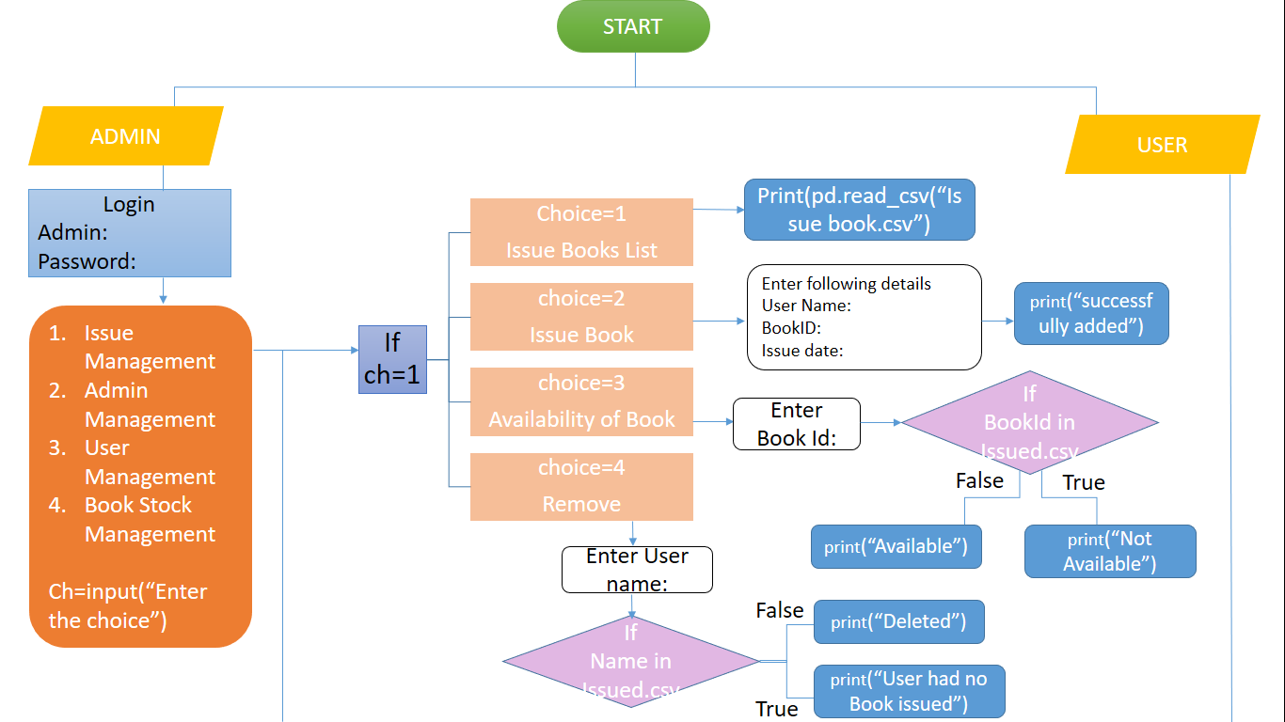

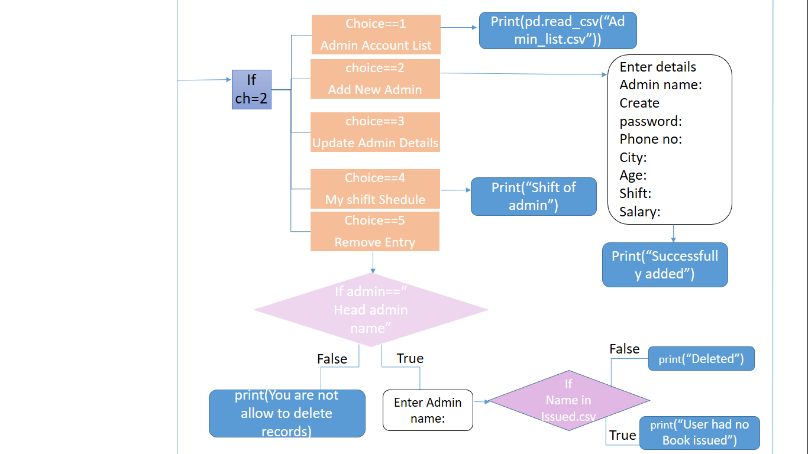

4

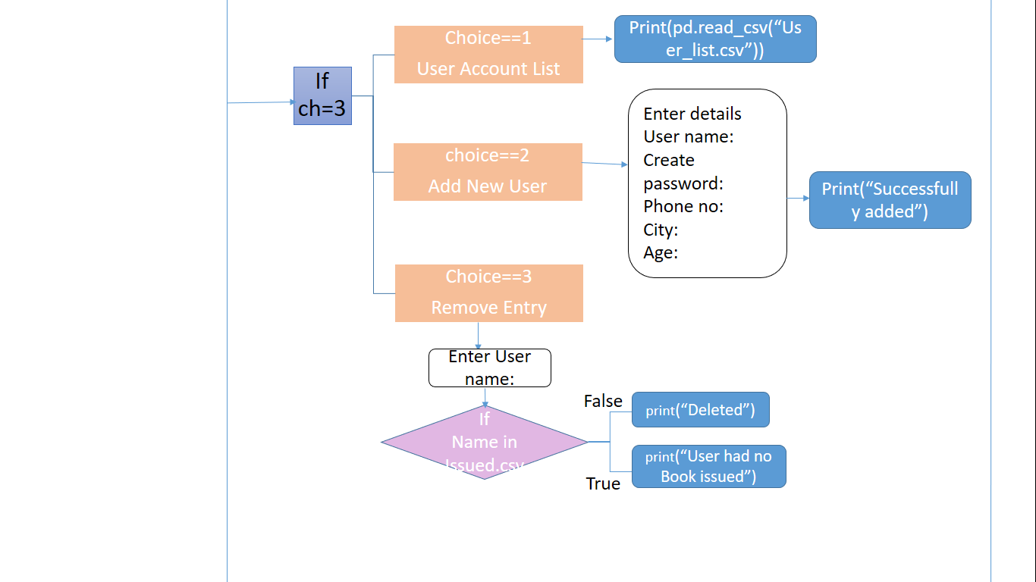

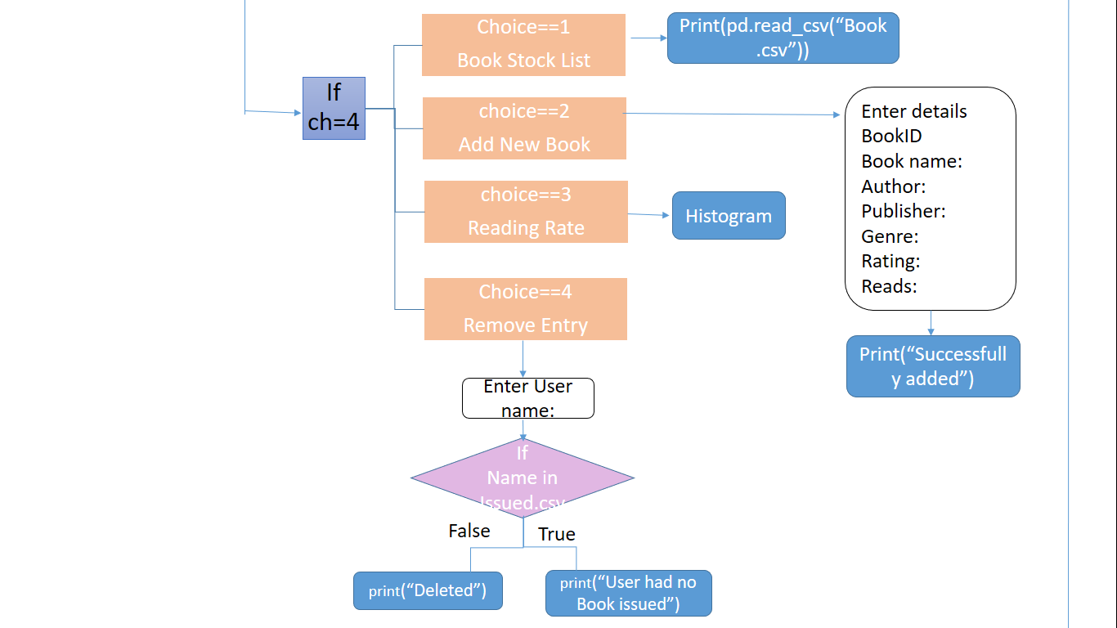

5

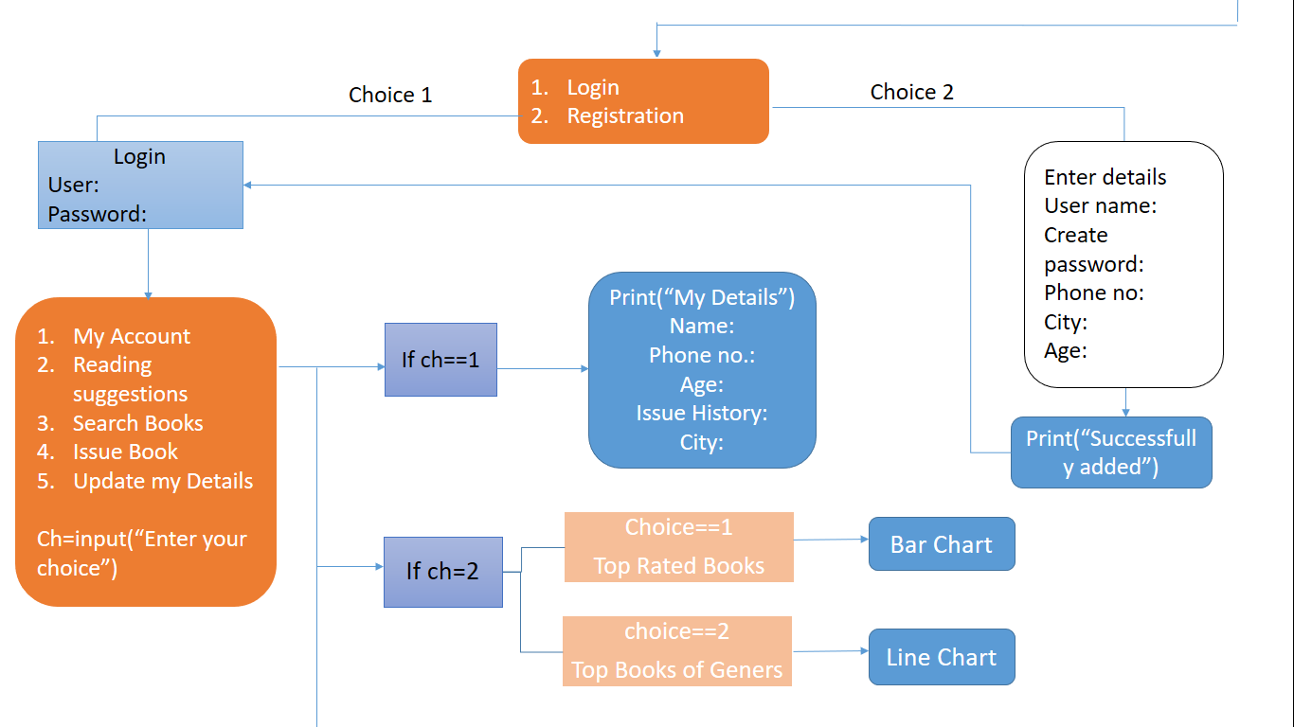

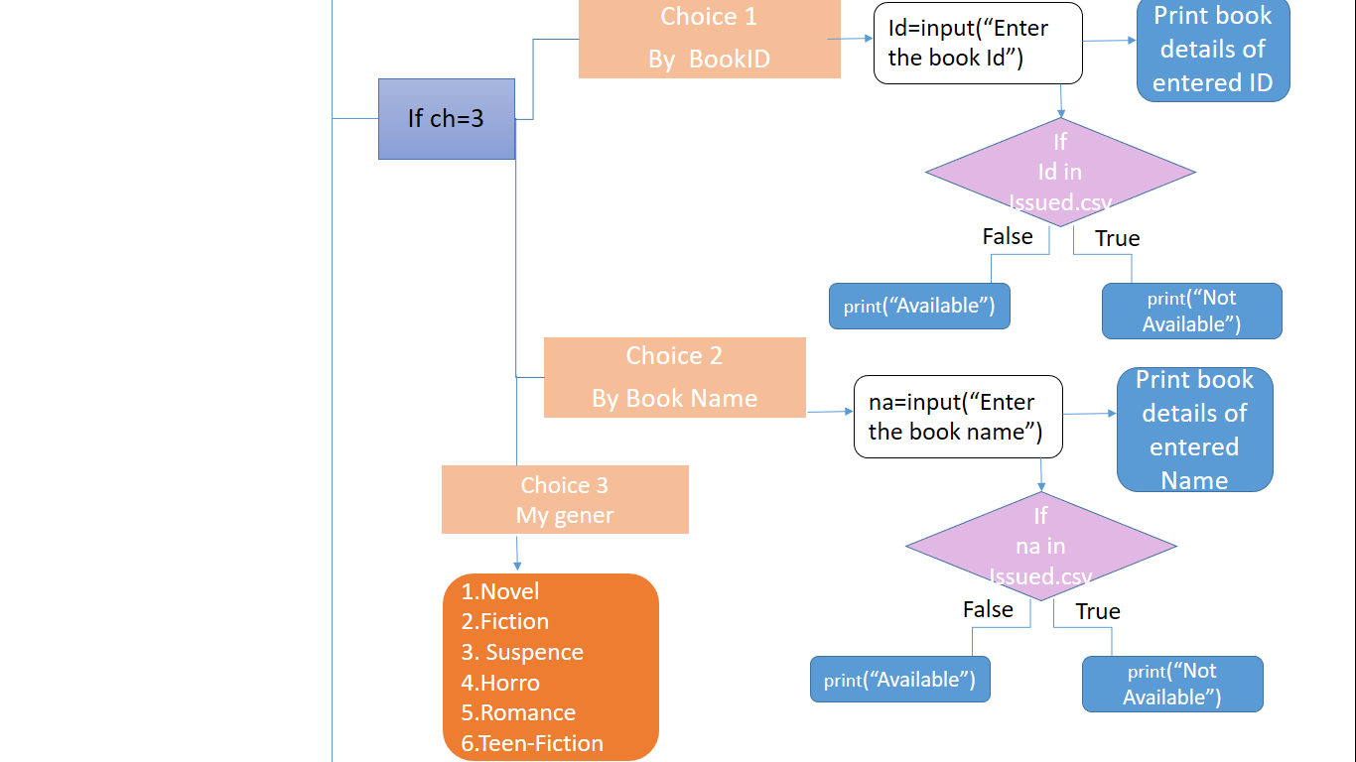

6

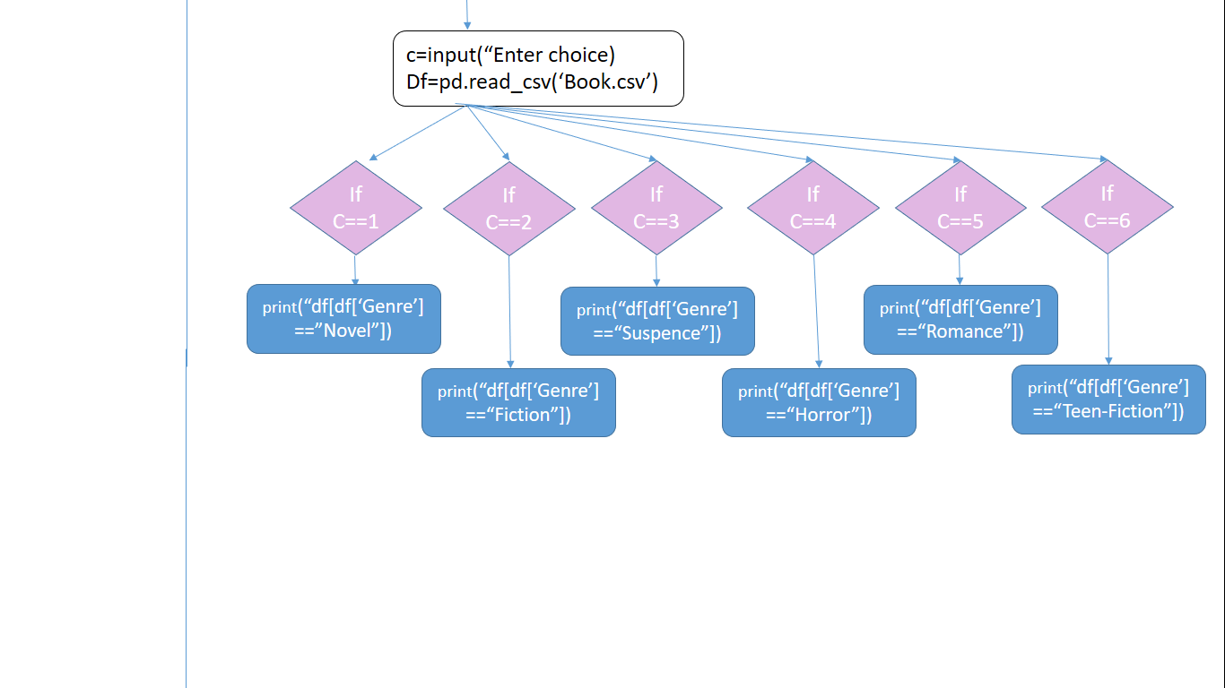

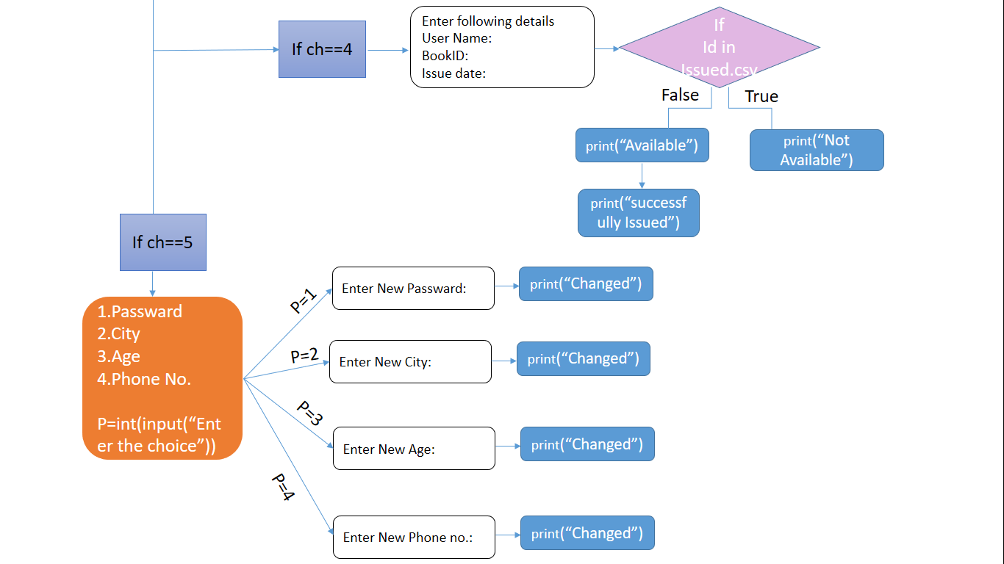

7

**File View**

**Python file name used:-**

* Library Project_cod.py

**CSV File used:-**

=>admin_list.csv => User_list.csv

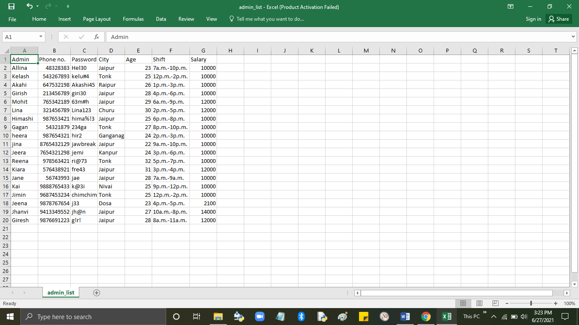 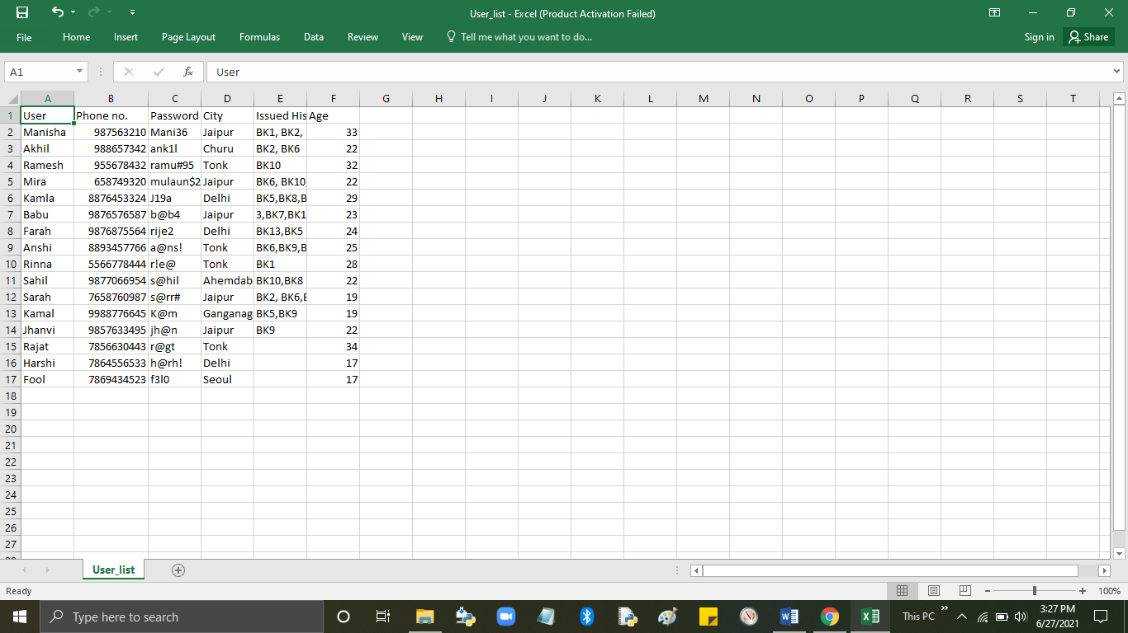

=>Book.csv =>Issued.csv

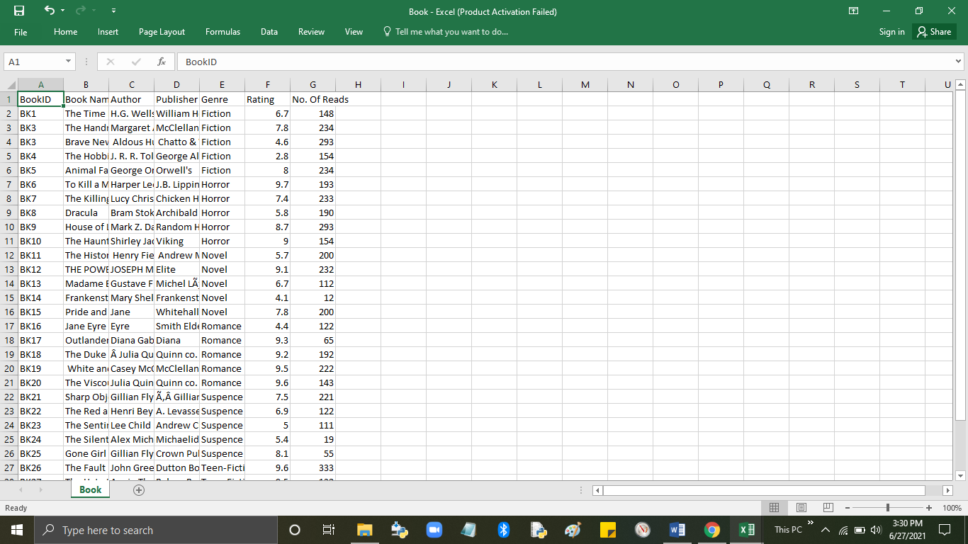 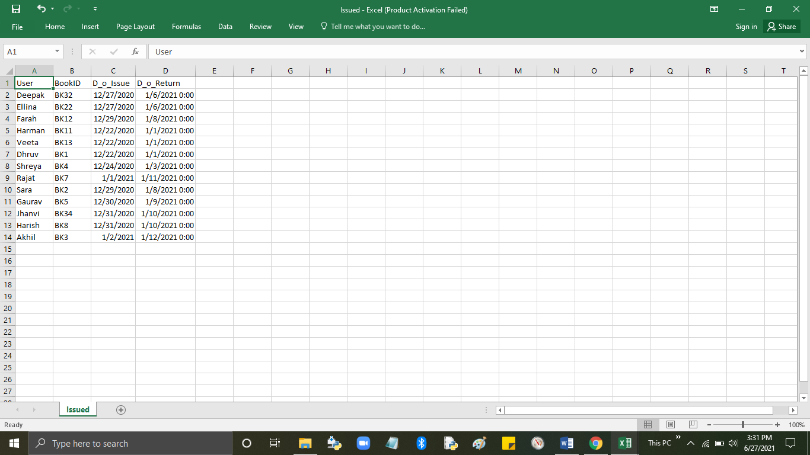

8

8

**SOURCE CODE**

import pandas as pd

import numpy as np

import csv

import matplotlib.pyplot as plt

import datetime

from datetime import date

from datetime import timedelta

print(" |************************|")

print("=:-------:{=|WELCOME TO ABYSS LIBRARY|=}:--------:=")

print(" |************************|")

m=1

while(m==1):

print(" |::::::::::::::::|")

print(" |: 1.ADMIN :|")

print(" |: 2.USER :|")

print(" |::::::::::::::::|")

a=int(input(" Enter your choice:"))

if(a==1):

print("______________________________")

ad=input("Enter the ADMIN name:")

pwd=input("Enter the Passward:")

df=pd.read_csv("admin_list.csv")

df1=df[(df['Admin']==ad) & (df['Password']==pwd)]

if(df1.empty):

print("=X= TRY AGAIN =X=")

m=1

else:

q=1

print("------||WELCOME ",ad,"||------")

while (q==1):

print("______________________________")

9

print("<<<<<<<<<<<<<<<<<<<<<<<<<<<<<< ")

print("1.Book Issue Management")

print("2.Admins Management")

print("3.Users Management")

print("4.Books Management")

print("5.===BACK===")

b=int(input("Enter your choice: "))

if(b==1):

w=1

while(w==1):

print("______________________________")

print("!!!!!!!!!!!!!!!!!!!!!!!!!!!!!!")

print("1. Book Issued list")

print("2. Issue Book")

print("3. Availablity of Book")

print("4. Remove Entry")

print("5. ==BACK==")

c=int(input("Enter your choice: "))

if(c==1):

df2=pd.read_csv('Issued.csv')

print("______________________________")

print(df2)

q=0

w=1

elif(c==2):

print("______________________________")

i=int(input("Enter the no. of entries:"))

for s in range(i):

print("______________________________")

print("Entry",s+1)

na=input("Enter User Name:")

bd=input("Enter BookID(One Book at a time):")

df2=pd.read_csv('Issued.csv')

10

df3=df2[df2["BookID"]== bd]

if df3.empty:

di=input("Enter Issue date(MM/DD/YYYY):")

date_1 = datetime.datetime.strptime(di, "%m/%d/%Y")

r = date_1 + datetime.timedelta(days=10)

df2=pd.read_csv('Issued.csv')

data={"User":[na],"BookID":[bd],"D_o_Issue":[di], "D_o_Return":[r]}

df3=pd.DataFrame(data)

df4=df2.append(df3)

df4.to_csv('Issued.csv',index=False)

df4=pd.read_csv('Issued.csv')

print("---SUCCESSFULLY ISSUED---")

print(" ^^^^^^^^^^^^^^^^^^^")

print(df4)

q=0

w=1

else:

print("--This Book is NOT available--")

print("It will be available after:", (df3['D_o_Return'].to_string(index=False)))

q=0

w=1

elif(c==3):

print(" ")

id=input("Enter the BookID(Example- BK1,BK2..): ")

df2=pd.read_csv('Issued.csv')

df3=df2[df2['BookID']==id]

if(df3.empty):

print("---THIS BOOK IS AVAILABLE---")

print(" ^^^^^^^^^^^^^^^^^^^^^^")

q=0

w=1

else:

11

print(" ")

print("--SORRY THIS BOOK IS Currently ISSUED--")

print(" ^^^^^^^^^^^^^^^^^^^^^^^^^^^^^^^^^^^")

print("It will be available after:", (df3['D_o_Return'].to_string(index=False)))

q=0

w=1

elif(c==6):

print(" ")

nam=input("Enter User Name: ")

df2=pd.read_csv('Issued.csv')

df3=df2[df2['User']==nam]

if(df3.empty):

print("-- No Book Issued under", nam, " --")

q=0

w=1

else:

print("Issue Date:", df3["D_o_Issue"].to_string(index=False))

print("Returning Date: ", df3["D_o_Return"].to_string(index=False))

re=input("Enter Returned date(mm/dd/yyYy):")

dd=input("No.Of Delay Days: ")

fe= dd*10

df4=df3["Returned on"].fillna(re)

df5=df4['Delay Days'].fillna(dd)

df6=df5['Fee'].fillna(fe)

print("Fee: Rs.10/day")

print("Here is your Recipt Mr./Ms.",nam)

print(df6)

print("Your pay=",(df6['Fee'].to_string(index=False)), "Rupees")

print("==Thanks for visiting==")

data2=(df2[df2['User']==nam].index.values)

df2=df2.drop(data2)

df2.to_csv('Issued.csv',index=False)

df2=pd.read_csv('Issued.csv')

12

q=0

w=1

elif(c==4):

print(" ")

add=input("Enter User Name you want to Delete: ")

df2=pd.read_csv('Issued.csv')

df3=df2[df2['User']==add]

if(df3.empty):

q=0

w=1

print("---This User Not Found---")

else:

data=(df2[df2['User']==add].index.values)

df2=df2.drop(data)

df2.to_csv('Issued.csv',index=False)

df2=pd.read_csv('Issued.csv')

q=0

w=1

print("=Succefully Deleted Entry=")

print(df2)

elif(c==5):

w=0

q=1

elif(b==2):

x=1

while x==1:

print("______________________________")

print("!!!!!!!!!!!!!!!!!!!!!!!!!!!!!!")

print("1. Admin Account List")

print("2. Add new Admin")

print("3. Update Admin Details")

print("4. My Shift Schedule")

print("5. Remove Entry")

13

print("6. ==BACK==")

c=int(input("Enter your choice: "))

if(c==1):

print(" ")

print(df)

q=0

x=1

elif(c==2):

print(" ")

i=int(input("Enter the no. of Entries"))

print("Enter the following details")

for s in range (i):

print(" ")

print("Entry",(s+1))

adn=input("Admin Name: ")

Pass=input("Create Password: ")

pn=input("Phoneno.: ")

ci=input("City: ")

ag=input("Age: ")

sh=input("shift: ")

sal=input("Salary: ")

df=pd.read_csv('admin_list.csv')

data={"Admin":[adn],"Password":[Pass], "Phone no.":[pn],"City":[ci],"Age":[ag],"Shift":[sh],"Salary":[sal]}

df2=pd.DataFrame(data)

df4=df.append(df2)

df4.to_csv('admin_list.csv',index=False)

df4=pd.read_csv('admin_list.csv')

print(" ")

print(df4)

print("-- SUCCESSFULLY ADDED--")

print(" ^^^^^^^^^^^^^^^^^^")

q=0

14

x=1

elif(c==3):

adn=input("Admin name whose detail you want to change")

df2=pd.read_csv('Admin_list.csv')

df3=df2[df2['Admin']==adn]

if(df3.empty):

q=0

x=1

print("--Admin not exists--")

else:

l=1

while l==1:

print("--WHAT YOU WANT TO CHANGE--")

print("1. Passward")

print("2. Age")

print("3. City")

print("4. Phone No.")

print("5. Shift")

print("6. Salary")

print("7. ==BACK==")

h=int(input("Enter your choice:"))

if h==1:

df2=pd.read_csv('Admin_list.csv')

pas=input("Enter New Password: ")

d=(df2[df2['Admin']==adn].index.values)

df2.loc[d,["Password"]]=pas

df2.to_csv('Admin_list.csv',index=False)

df3=df2[df2['Admin']==adn]

print(df3)

print("==Successfully changed==")

l=1

q=0

x=0

15

elif h==2:

df2=pd.read_csv('Admin_list.csv')

pas=input("Enter New Age: ")

d=(df2[df2['Admin']==adn].index.values)

df2.loc[d,["Age"]]=pas

df2.to_csv('Admin_list.csv',index=False)

df3=df2[df2['Admin']==adn]

print(df3)

print("==Successfully changed==")

l=1

q=0

x=0

elif h==3:

df2=pd.read_csv('Admin_list.csv')

pas=input("Enter New City: ")

d=(df2[df2['Admin']==adn].index.values)

df2.loc[d,["City"]]=pas

df2.to_csv('Admin_list.csv',index=False)

df3=df2[df2['Admin']==adn]

print(df3)

print("==Successfully changed==")

l=1

q=0

x=0

elif h==4:

df2=pd.read_csv('Admin_list.csv')

pas=input("Enter New Phone no.: ")

d=(df2[df2['Admin']==adn].index.values)

df2.loc[d,["Phone no."]]=pas

df2.to_csv('Admin_list.csv',index=False)

df3=df2[df2['Admin']==adn]

print(df3)

print("==Successfully changed==")

16

l=1

q=0

x=0

elif h==5:

df2=pd.read_csv('Admin_list.csv')

pas=input("Enter New Shift: ")

d=(df2[df2['Admin']==adn].index.values)

df2.loc[d,["Shift"]]=pas

df2.to_csv('Admin_list.csv',index=False)

df3=df2[df2['Admin']==adn]

print(df3)

print("==Successfully changed==")

l=1

q=0

x=0

elif h==6:

df2=pd.read_csv('Admin_list.csv')

pas=input("Enter New Salary: ")

d=(df2[df2['Admin']==adn].index.values)

df2.loc[d,["Salary"]]=pas

df2.to_csv('Admin_list.csv',index=False)

df3=df2[df2['Admin']==adn]

print(df3)

print("==Successfully changed==")

l=1

q=0

x=0

elif h==7:

l=0

q=0

x=1

else:

print("--Enter the correct choise--")

17

l=1

q=0

x=0

elif (c==4):

print(" ")

print(ad, ",your shift will be from: ",(df1["Shift"].to_string(index=False)))

q=0

x=1

elif (c==5):

if (ad== "Jhanvi"):

print(" ")

add=input("Enter Admin you want to Delete: ")

df2=pd.read_csv('admin_list.csv')

df3=df2[df2['Admin']==add]

if(df3.empty):

q=0

x=1

print("---This Admin already not exists---")

else:

data=(df2[df2['Admin']==add].index.values)

df2=df2.drop(data)

df2.to_csv('admin_list.csv',index=False)

df2=pd.read_csv('admin_list.csv')

q=0

x=1

print("-- ", add, " record is successfully deleted. --")

else:

print("--Sorry you are not allowed to remove staff details--")

print("--ONLY HEAD ADMIN 'Jhanvi' is allowed--")

q=0

x=1

elif (c==6):

x=0

18

q=1

elif(b==3):

y=1

while y==1:

print("______________________________")

print("!!!!!!!!!!!!!!!!!!!!!!!!!!!!!!")

print("1. User Account List")

print("2. Add new User")

print("3. Remove Entry")

print("4. ==BACK==")

c=int(input("Enter your choice:"))

if(c==1):

df2=pd.read_csv('User_list.csv')

print(df2)

q=0

y=1

elif(c==2):

i=int(input("Enter the no. of Entries:"))

print("Enter the following")

for s in range (i):

print("Entry",(s+1))

u=input("User Name")

Pass=input("Create Password")

pn=input("Phoneno.: ")

ci=input("City: ")

ag=input("Age:")

df=pd.read_csv('User_list.csv')

data={"User":[u],"Password":[Pass], "Phone no.":[pn],"City":[ci],"Age":[ag]}

df2=pd.DataFrame(data)

df4=df.append(df2)

df4.to_csv('User_list.csv',index=False)

df4=pd.read_csv('User_list.csv')

print(df4)

19

print("--SUCCESSFULLY ADDED--")

q=0

y=1

elif (c==3):

add=input("Enter User Name you want to Delete: ")

df2=pd.read_csv('User_list.csv')

df3=df2[df2['User']==add]

if(df3.empty):

q=0

y=1

print("User already not exists")

else:

data=(df2[df2['User']==add].index.values)

df2=df2.drop(data)

df2.to_csv('User_list.csv',index=False)

df2=pd.read_csv('User_list.csv')

q=0

y=1

print("=X= ", add, " record is successfully deleted. =X=")

elif (c==4):

y=0

q=1

elif(b==4):

k=1

while k==1:

print("______________________________")

print("!!!!!!!!!!!!!!!!!!!!!!!!!!!!!!")

print("1. Books List")

print("2. Add new Book")

print("3. Reading Rate(Histogram)")

print("4. Remove Entry")

print("5. ==BACK==")

c=int(input("Enter your choice:"))

20

if(c==1):

print(" ")

df2=pd.read_csv("Book.csv")

print(df2)

q=0

k=1

elif(c==2):

print(" ")

i=int(input("Enter the no. of Entries"))

print("Enter the following details")

for s in range (i):

print(" ")

print("Entry",(s+1))

bi=input("Book ID:")

bn=input("Book Name:")

au=input("Auther")

pu=input("Publisher: ")

g=input("Genre: ")

ra=input("Rating: ")

r=input("No. of reads")

df=pd.read_csv('Book.csv')

data={"BookID":[bi],"Book Name":[bn], "Author":[au],"Publisher":[pu],"Genre":[g],"Rating":[ra], "No. Of Reads": [r]}

df2=pd.DataFrame(data)

df4=df.append(df2)

df4.to_csv('Book.csv',index=False)

df4=pd.read_csv('Book.csv')

print(df4)

print("--SUCCESSFULLY ADDED--")

q=0

k=1

elif (c==3):

gr=pd.read_csv('Book.csv')

21

plt.hist(gr['No. Of Reads'])

plt.title("=| No. of Books as per reads |=",fontsize=15)

plt.xlabel("No.of Reads",fontsize=10)

plt.ylabel("No. of Books",fontsize=10)

plt.show()

q=0

k=1

elif (c==4):

print(" ")

add=input("Enter Book Name you want to Delete: ")

df2=pd.read_csv('Book.csv')

df3=df2[df2['Book Name']==add]

if(df3.empty):

q=0

k=1

print("Book already not exists")

else:

data=(df2[df2['Book Name']==add].index.values)

df2=df2.drop(data)

df2.to_csv('Book.csv',index=False)

df2=pd.read_csv('Book.csv')

q=0

k=1

print("--SUCCESSFULLY DELETED--")

elif (c==5):

k=0

q=1

elif (b==5):

q=0

if(a==2):

q=1

while (q==1):

print(" ")

22

print(" |-*-*-*-*-*-*-*-*-*-*-|")

print(" |* 1. LOGIN *|")

print(" |* 2. REGISTRATION *|")

print(" |* 3. ==BACK== *|")

print(" |-*-*-*-*-*-*-*-*-*-*-|")

df=pd.read_csv("User_list.csv")

f=int(input(" Enter the choise:"))

if(f==1):

print("_______________________")

u=input("Enter the User name:")

pwd=input("Enter the Passward:")

df1=df[(df['User']==u) & (df['Password']==pwd)]

if(df1.empty):

print(":=X= Try Again =X=:")

print("Please Enter Correct Details")

q=1

else:

s=1

print(":-:-|*|HELLO ",u,"|*|-:-:")

while s==1:

print("|---------------------------|")

print("|! 1. My Account !|")

print("|! 2. Reading Suggestions !|")

print("|! 3. Search Books !|")

print("|! 4. Issue Book !|")

print("|! 5. Update MY details !|")

print("|! 6. ==BACK== !|")

print("|---------------------------|")

b=int(input("Enter your choice: "))

if (b==1):

print(" ")

print("ooo:| WELCOME TO YOUR ACCOUNT ",u,"|:ooo")

print(" My DETAILS")

23

print(" ^^^^^^^^^^")

print("Name : ", df1['User'].to_string(index=False))

print("Age : ",df1['Age'].to_string(index=False))

print("PhoneNo. : ",df1['Phone no.'].to_string(index=False))

print("City : ",df1['City'].to_string(index=False))

print("Issued History: ",df1['Issued History'].to_string(index=False))

print("")

s=1

q=0

elif (b==2):

t=1

while (t==1):

print("__________________________")

print("|************************|")

print("| ---SUGGESTION BOARD--- |")

print("| 1. Top Rating |")

print("| 2. Toppers of Genres |")

print("| 3. ===BACK=== |")

print("|************************|")

p=int(input("Enter your choise: "))

if p==1:

gr=pd.read_csv("Book.csv")

gr1=gr.sort_values('Rating', ascending=False)

plt.bar(gr1['BookID'],gr1['Rating'])

plt.title("Top Rated Books",fontsize=20)

plt.xlabel('Book Name',fontsize=10)

plt.ylabel('Rating',fontsize=10)

plt.grid()

plt.show()

t=1

q=0

s=0

elif p==2:

24

gr=pd.read_csv("Book.csv")

gr=pd.read_csv("Book.csv")

df2=gr[gr['Genre']== "Novel"]

df3=gr[gr['Genre']== "Fiction"]

df4=gr[gr['Genre']== "Suspence"]

df5=gr[gr['Genre']== "Romance"]

df6=gr[gr['Genre']== "Horror"]

df7=gr[gr['Genre']== "Teen-Fiction"]

plt.plot(df2.BookID, df2['Rating'], 'yellow', label='NOVEL')

plt.plot(df3.BookID, df3['Rating'], 'red', label='FICTION')

plt.plot(df4.BookID, df4['Rating'], 'blue', label='SUSPENCE')

plt.plot(df5.BookID, df5['Rating'], 'pink', label='ROMANCE')

plt.plot(df6.BookID, df6['Rating'], 'black', label='HORROR')

plt.plot(df7.BookID, df7['Rating'], 'green', label='TEEN-FICTION')

plt.legend(loc='upper left')

plt.title("=|Top Rated Books(Genre Wise)|= \n -Zoom the gener section you are interested-",fontsize=20)

plt.xlabel('Book Name',fontsize=10)

plt.ylabel('Ratings',fontsize=10)

plt.grid()

plt.show()

t=1

q=0

s=0

elif p==3:

t=0

q=0

s=1

else:

print("x-x-x-x-Enter the correct choise-x-x-x-x")

t=1

q=0

s=0

25

elif (b==3):

v=1

while v==1:

print("|-----------------------|")

print("| = SEARCH METHODS = |")

print("| 1. By BOOK ID |")

print("| 2. By BOOK NAME |")

print("| 3. My Genre Books |")

print("| 4. ==BACK== |")

print("|-----------------------|")

sm=int(input("Enter your Choise: "))

if sm==1:

i=input("Enter the Book ID")

df2=pd.read_csv('Book.csv')

df3=pd.read_csv('Issued.csv')

df4=df2[df2['BookID']== i]

print(df4)

df5=df3[df3['BookID']==i]

if df5.empty:

print("--This Book Is Available in Our Library--")

print("--Get the Book ID and Please go back If you want to Issue This Book--")

v=1

q=0

s=0

else:

print("--THIS BOOK IS Currently ISSUED--")

print("It will be available after:", (df5['D_o_Return'].to_string(index=False)))

v=1

q=0

s=0

elif sm==2:

26

am=input("Enter the Book Name")

df2=pd.read_csv('Book.csv')

df3=pd.read_csv('Issued.csv')

df4=df2[df2['Book Name']== am]

print(df4)

df5=df3[df3['BookID']==i]

if df5.empty:

print("--This Book Is Available in Our Library--")

print("--Get the Book ID and Please go back If you want to Issue This Book--")

v=1

q=0

s=0

else:

print("--THIS BOOK IS Currently ISSUED--")

print("It will be available after:", (df5['D_o_Return'].to_string(index=False)))

v=1

q=0

s=0

elif sm==3:

print("|-----------------------| ")

print("| AVAILABLE GENRES |")

print("| 1. Fiction |")

print("| 2. Novel |")

print("| 3. Suspence |")

print("| 4. Romance |")

print("| 5. Horror |")

print("| 6. Teen-Fiction |")

print("| 7. ==Back== |")

print("|-----------------------|")

g=int(input("Enter your choise: "))

mg=pd.read_csv('Book.csv')

27

if g==1:

ng=mg[mg['Genre']== "Fiction"]

print(ng)

v=1

q=0

s=0

elif g==2:

ng=mg[mg['Genre']== "Novel"]

print(ng)

v=1

q=0

s=0

elif g==3:

ng=mg[mg['Genre']== "Suspence"]

print(ng)

v=1

q=0

s=0

elif g==4:

ng=mg[mg['Genre']== "Romance"]

print(ng)

v=1

q=0

s=0

elif g==5:

ng=mg[mg['Genre']== "Horror"]

print(ng)

v=1

q=0

s=0

elif g==6:

ng=mg[mg['Genre']== "Teen-Fiction"]

print(ng)

28

v=1

q=0

s=0

else:

v=1

q=0

s=0

elif sm==4:

v=0

q=0

s=1

else:

print("--Enter correct choise--")

v=1

q=0

s=0

elif (b==4):

print(":-:-:-:-:-:-:-:-:-:-:-:")

df2=pd.read_csv('Book.csv')

df3=pd.read_csv('Issued.csv')

na=input("Enter Your Name:")

i=input("Enter the BookID")

df5=df3[df3['BookID']==i]

if df5.empty:

print("--This Book Is Available in Our Library--")

di=input("Enter Issue date(MM/DD/YYYY):")

date_1 = datetime.datetime.strptime(di, "%m/%d/%Y")

r = date_1 + datetime.timedelta(days=10)

df3=pd.read_csv('Issued.csv')

data={"User":[na],"BookID":[i],"D_o_Issue":[di], "D_o_Return":[r]}

df4=pd.DataFrame(data)

df5=df3.append(df4)

df5.to_csv('Issued.csv',index=False)

29

df5=pd.read_csv('Issued.csv')

df6=df5[df5['User']== na]

print(df6)

print("---SUCCESSFULLY ISSUED---")

print("Enjoy your read and return the book with in 10 days of issue date i.e.: ", df6['D_o_Return'].to_string(index=False))

q=0

s=1

else:

print("--THIS is already Issued--")

print("It will be availabel after: ", (df5['D_o_Return'].to_string(index=False)))

q=0

s=1

elif b==5:

l=1

while l==1:

print("|=============================|")

print("| --WHAT YOU WANT TO CHANGE-- |")

print("| 1. Passward |")

print("| 2. Age |")

print("| 3. City |")

print("| 4. Phone No. |")

print("| 5. ==BACK== |")

print("|=============================|")

c=int(input("Enter your choice:"))

if c==1:

df2=pd.read_csv('User_list.csv')

pas=input("Enter New Password: ")

d=(df2[df2['User']==u].index.values)

df2.loc[d,["Password"]]=pas

df2.to_csv('User_list.csv',index=False)

df3=df2[df2['User']== u]

print(df3)

30

print("==Successfully changed==")

l=1

q=0

s=0

elif c==2:

df2=pd.read_csv('User_list.csv')

pas=input("Enter Current new Age: ")

d=(df2[df2['User']==u].index.values)

df2.loc[d,["Age"]]=pas

df2.to_csv('User_list.csv',index=False)

df3=df2[df2['User']== u]

print(df3)

print("==Successfully changed==")

l=1

q=0

s=0

elif c==3:

df2=pd.read_csv('User_list.csv')

pas=input("Enter New City: ")

d=(df2[df2['User']==u].index.values)

df2.loc[d,["City"]]=pas

df2.to_csv('User_list.csv',index=False)

df3=df2[df2['User']== u]

print(df3)

print("==Successfully changed==")

l=1

q=0

s=0

elif c==4:

df2=pd.read_csv('User_list.csv')

pas=input("Enter New Phone no: ")

d=(df2[df2['User']==u].index.values)

df2.loc[d,["Phoneno."]]=pas

31

df2.to_csv('User_list.csv',index=False)

df3=df2[df2['User']== u]

print(df3)

print("==Successfully changed==")

l=1

q=0

s=0

elif c==5:

l=0

q=0

s=1

else:

print("x-x-x-x-Enter the correct choise-x-x-x-x")

l=1

q=0

s=0

elif(b==6):

q=1

s=0

else:

print("x-x-x-x-Enter the correct choise-x-x-x-x")

q=1

s=0

elif (f==2):

print(" ")

print("!==============================================!")

print("!-Please Enter the following details carefully-!")

print("!==============================================!")

u=input(" User Name: ")

Pass=input(" Create Password: ")

pn=input(" Phoneno.: ")

ci=input(" City: ")

ag=input(" Age: ")

32

df=pd.read_csv('User_list.csv')

data={"User":[u],"Password":[Pass], "Phone no.":[pn],"City":[ci],"Age":[ag]}

df2=pd.DataFrame(data)

df4=df.append(df2)

df4.to_csv('User_list.csv',index=False)

df4=pd.read_csv('User_list.csv')

print("---Successfully Registered---")

print("")

print("xxxx--WELCOME TO ABYSS READING WORLD--xxxx")

print(" ^^^^^^^^^^^^^^^^^^^^^^^^^^^^^^")

q=1

elif(f==3):

q=0

m=1

else:

print("x-x-x-x-Enter the correct choise-x-x-x-x")

q=0

m=1

else:

print("x-x-x-x-Enter the correct choise-x-x-x-x")

m=1**OUTPUT**

33

* Admin
* LOGIN:-

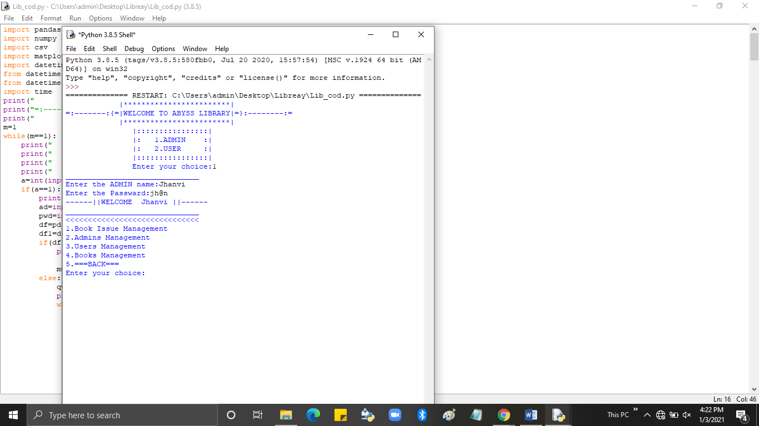

* Book Issue Management:-
  + Issued Book List-(Admin can see the whole list of issued Books)

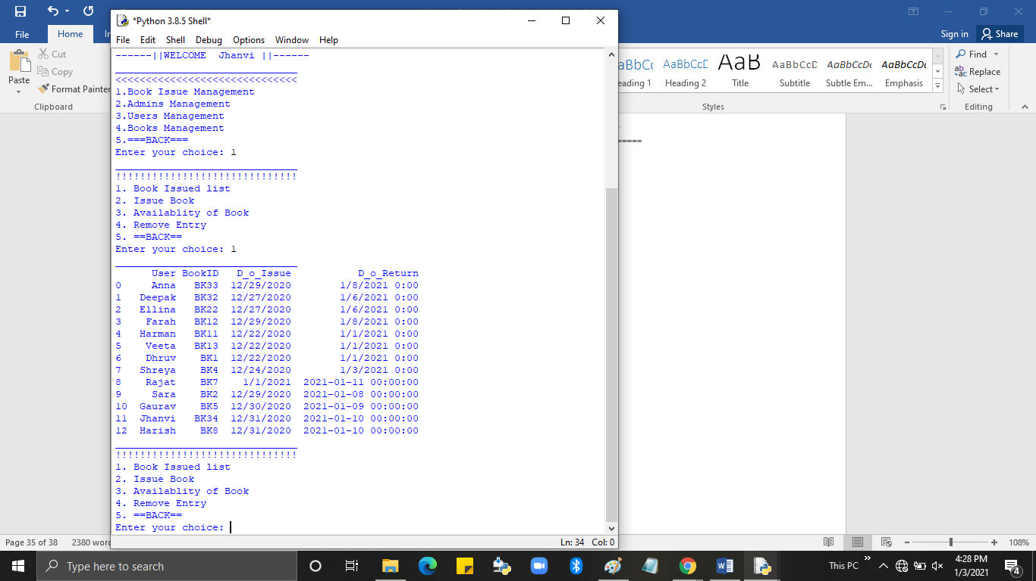

34

* + Availability of Book-(Admin can check a specific Book is available in Library or issued.)

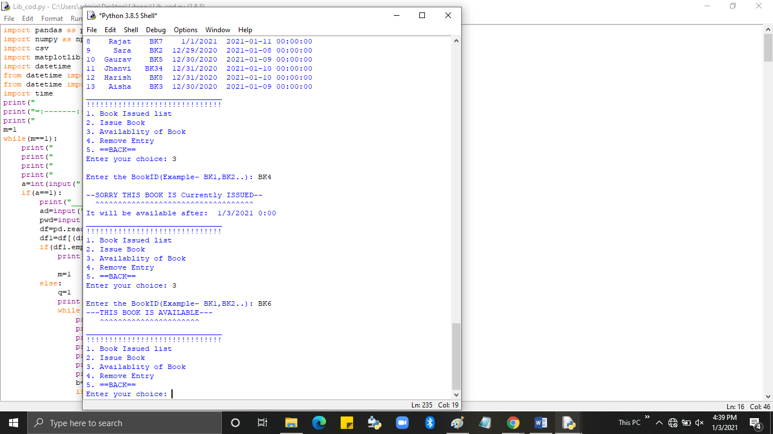

* + **Issue Book**- (Admin can Issue Books for costumers and tell its available or not)

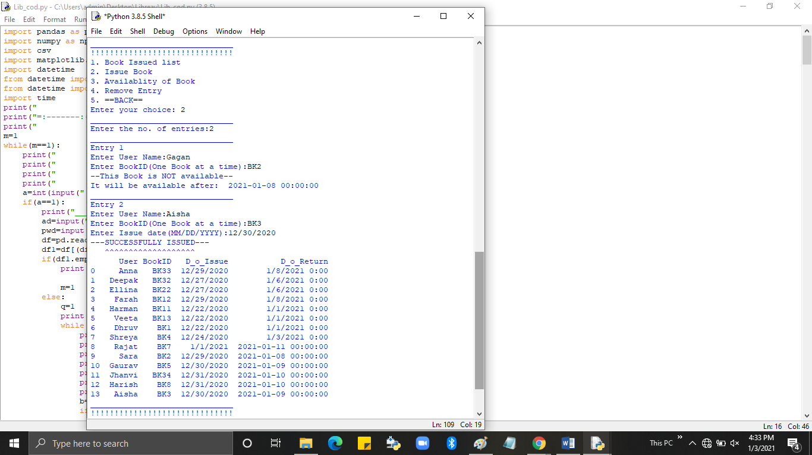

35

* + Remove Entry-(Admin can remove record of costumer who issued book, after he/she return)

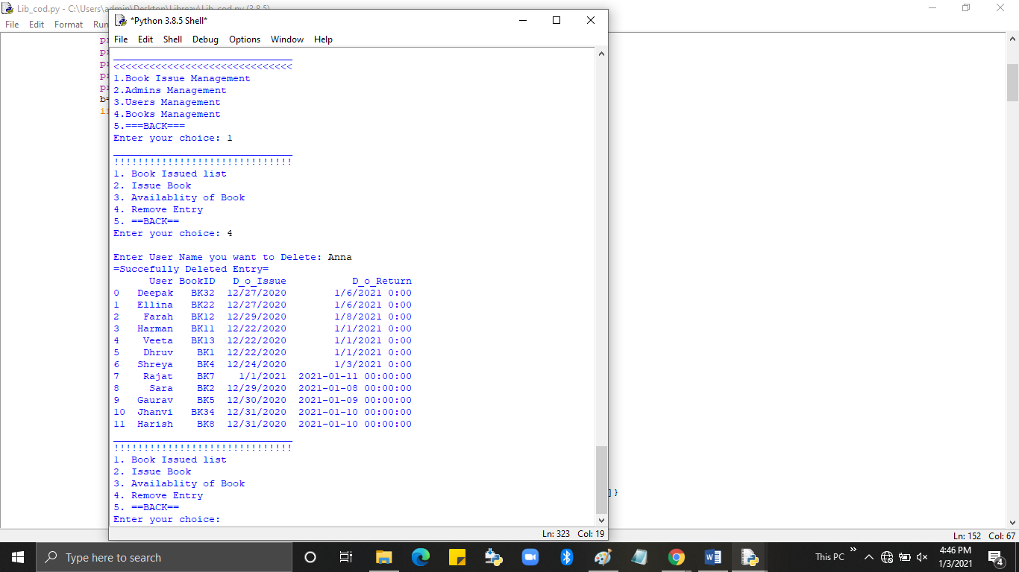

* Admin Management
  + 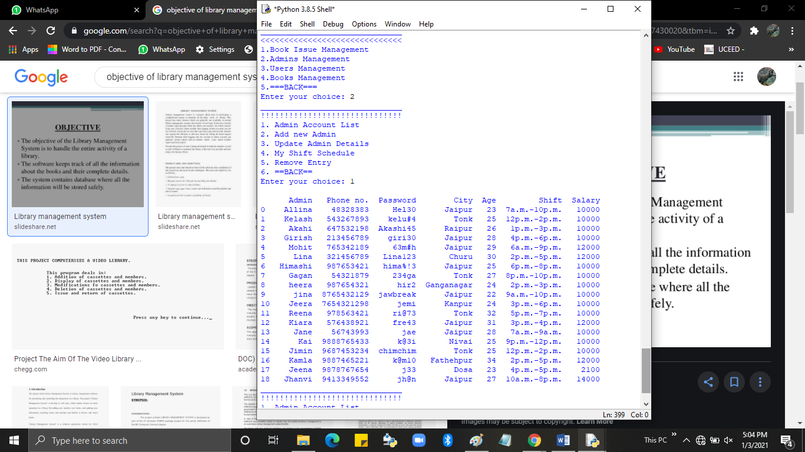Amin Account List- (Admin can see the other staff members details)

36

* + Add new-(Admin can add new admin/staff member)

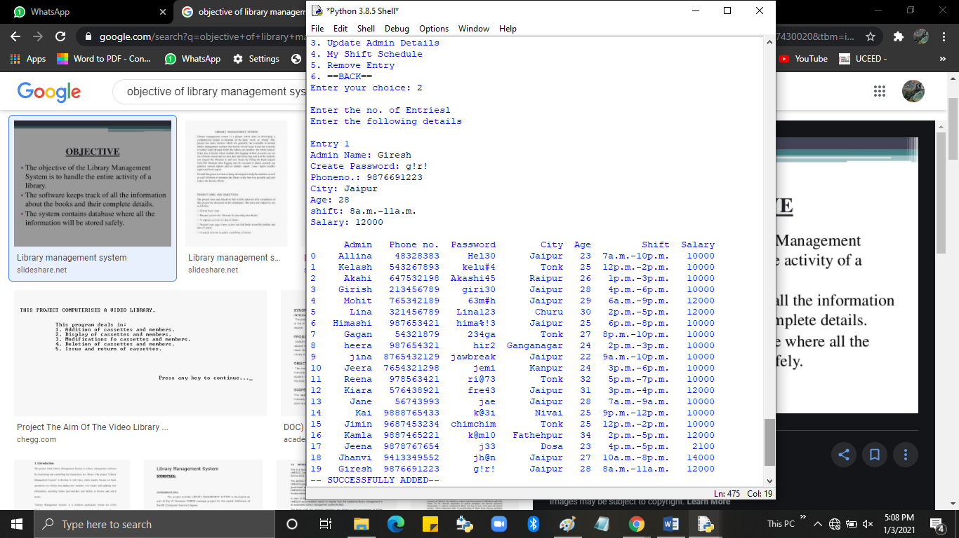

* + My Shift-(Admin can check his/her shift scheduled.)

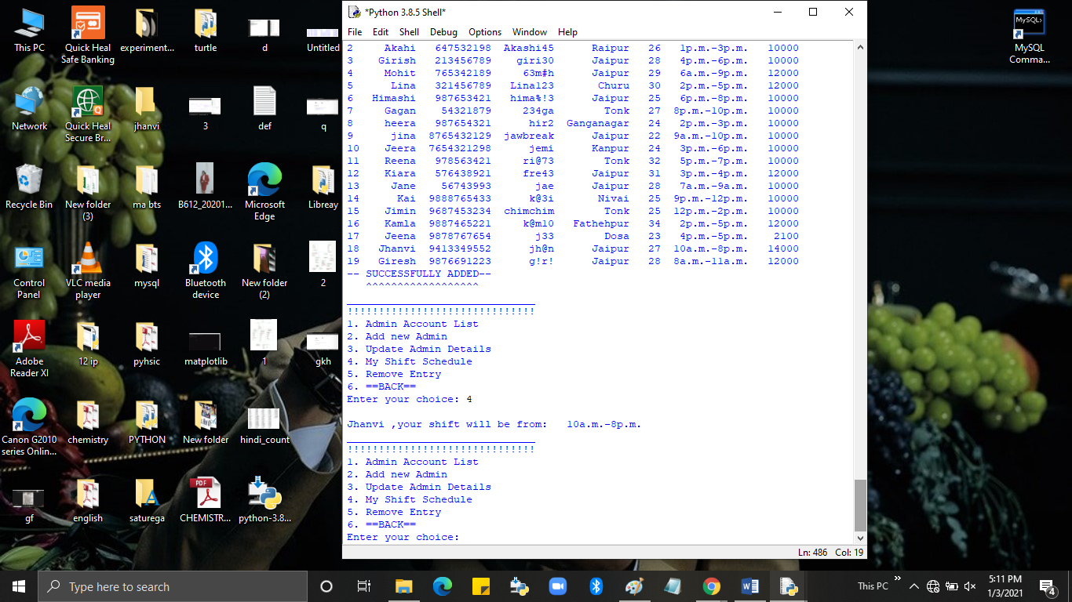

37

* + Update details-(Admin can update/modify details of other users as well as his/her own.)

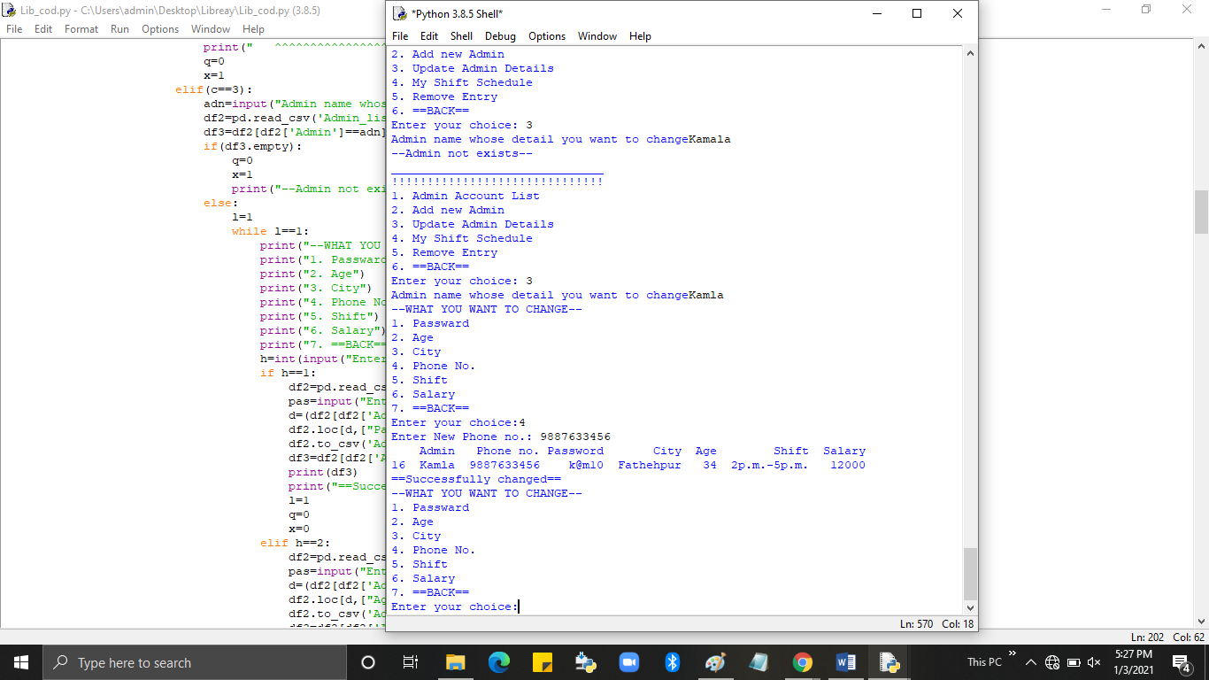

* + Remove Entry-(Delete other admins accounts.)

[When head admin login]

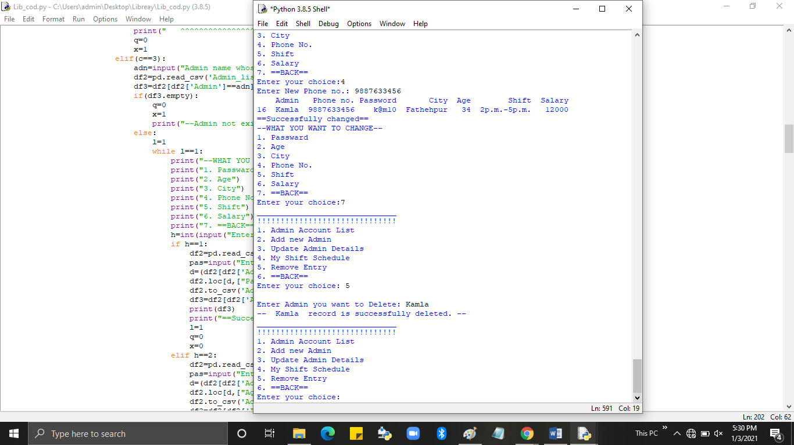

[When admin login]

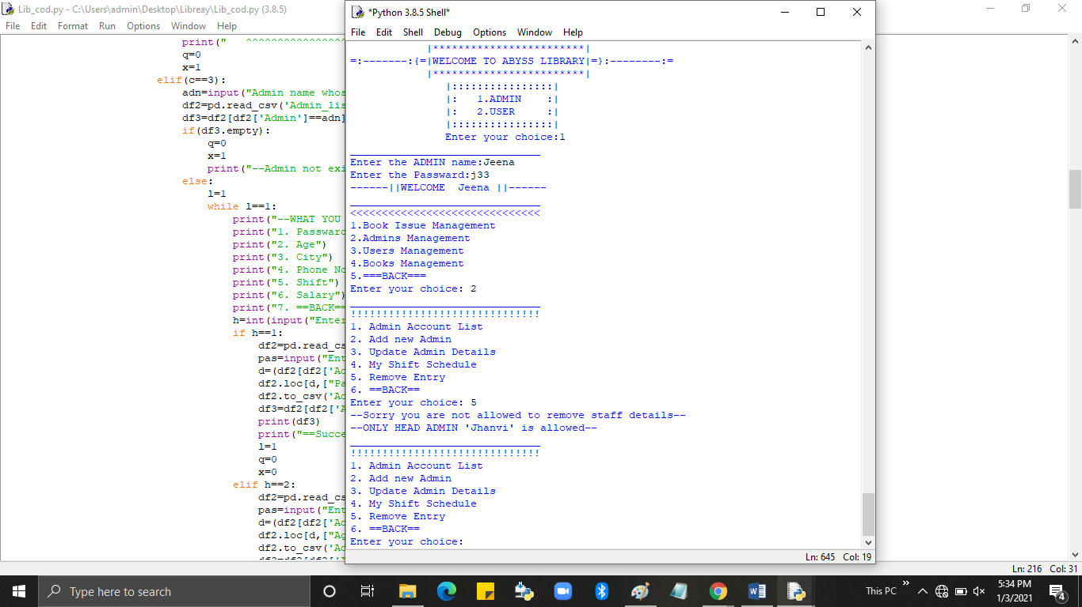

38

* User Management
  + User Account list-(Admin can view readers details)

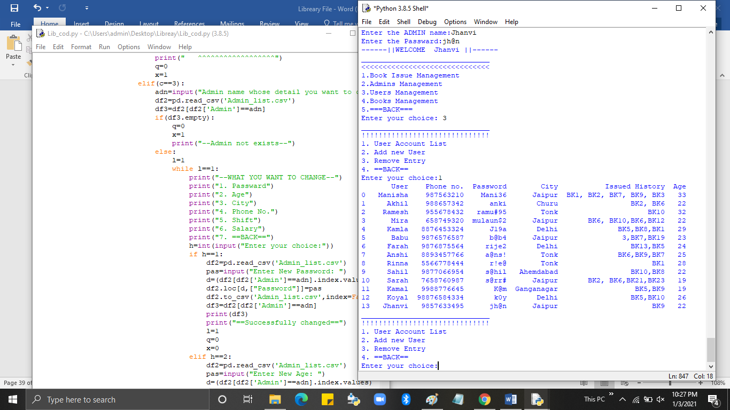

* + Add new user-(Admin can add new customer account)

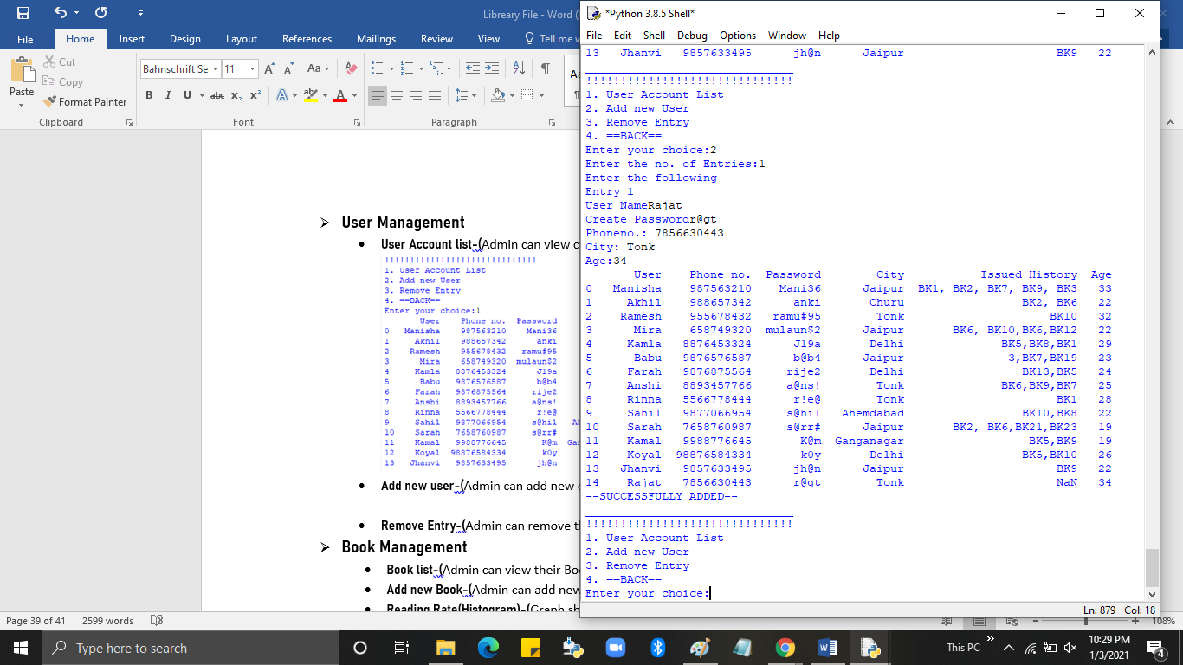

39

* + Remove Entry-(Admin can remove the customer account)

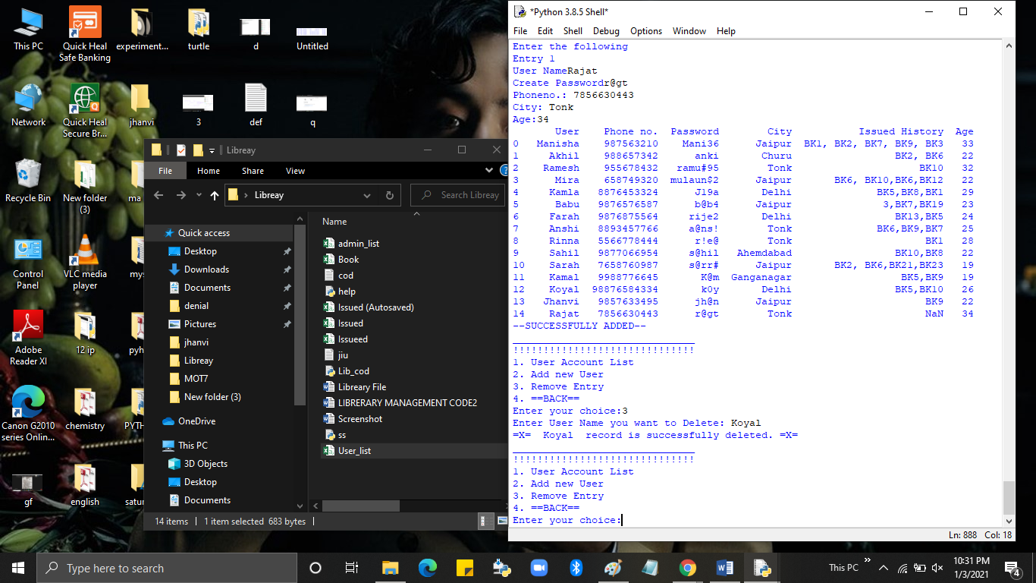

* Book Management
* Book list-(Admin can view their Books stock)

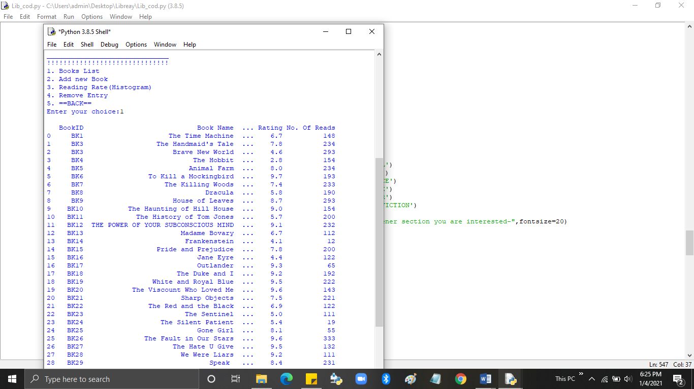

40

* Add new Book-(Admin can add new book in stock)

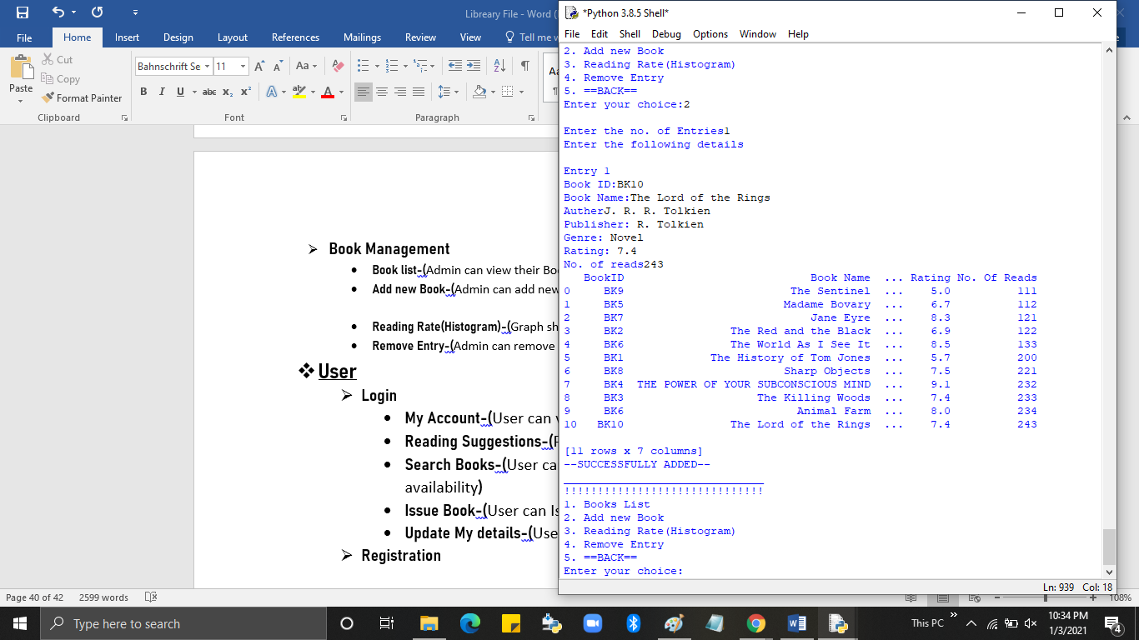

* Reading Rate(Histogram)-(Graph shows the no. of Books having specific reads)

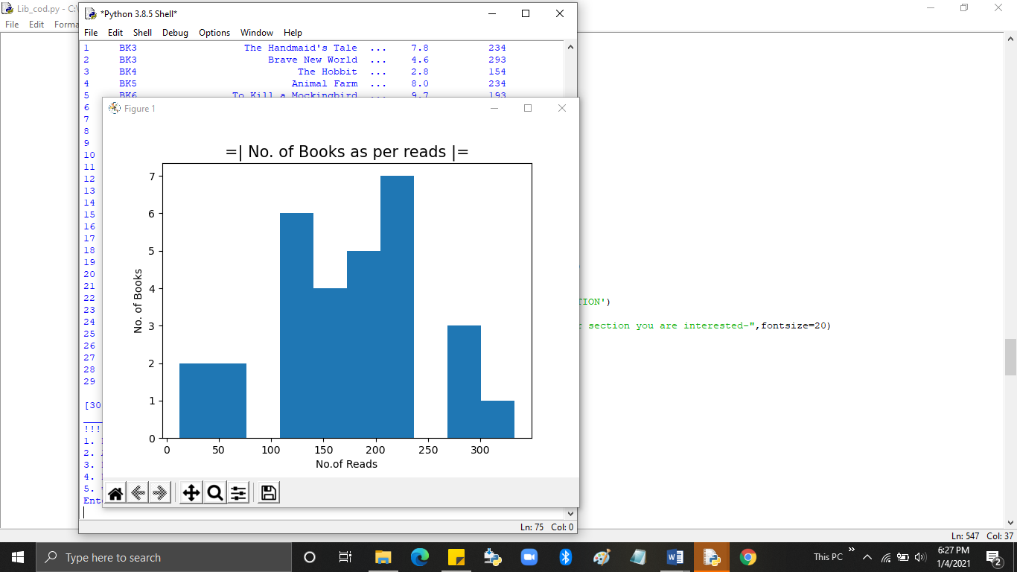

41

* Remove Entry-(Admin can remove Book details from stock)

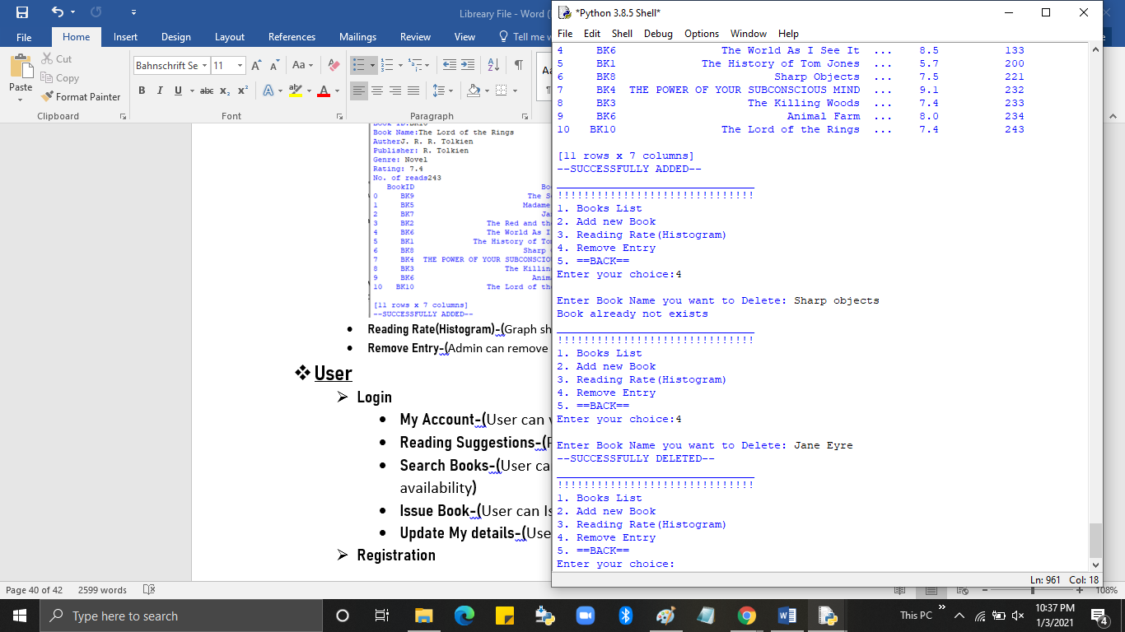

* User
* Login

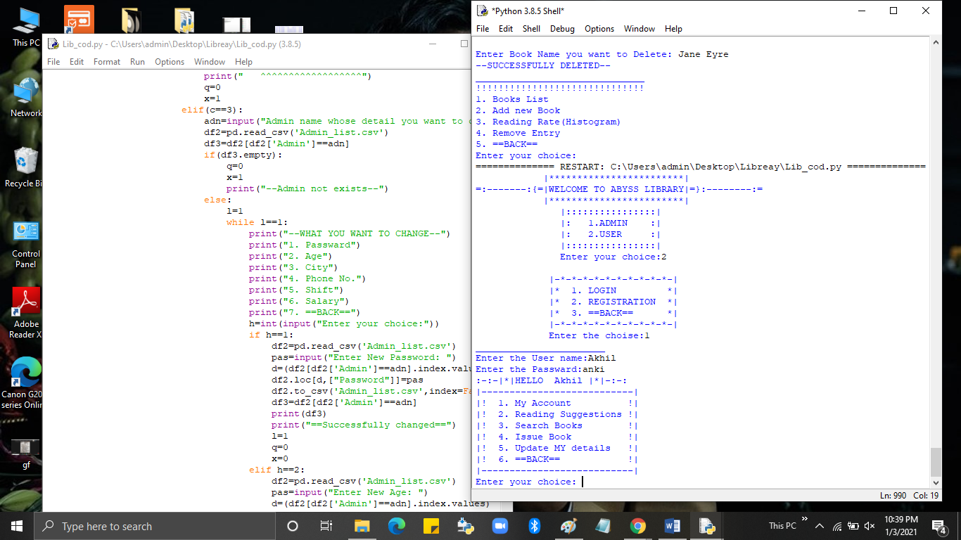

42

* My Account-(User can view his/her details)

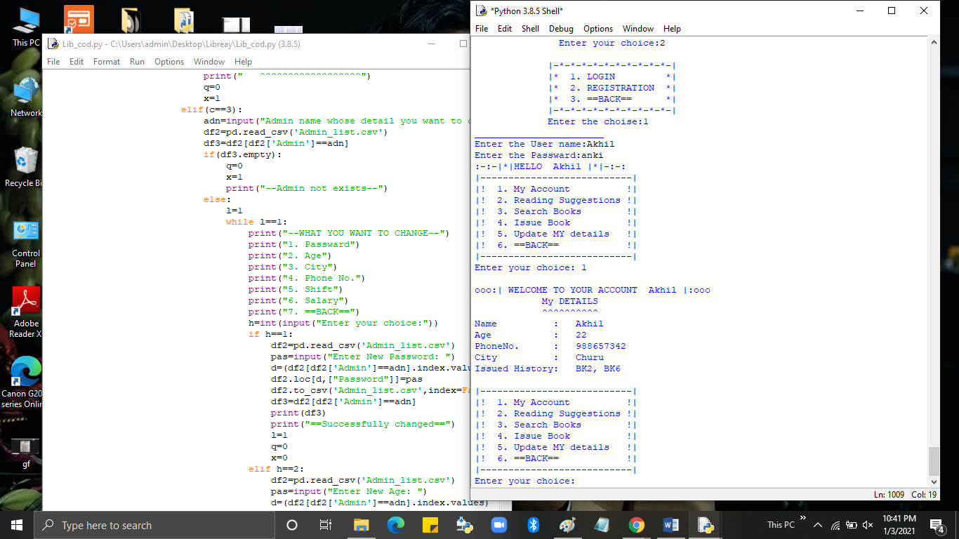

* Reading Suggestions-(Provide graph to compare books)

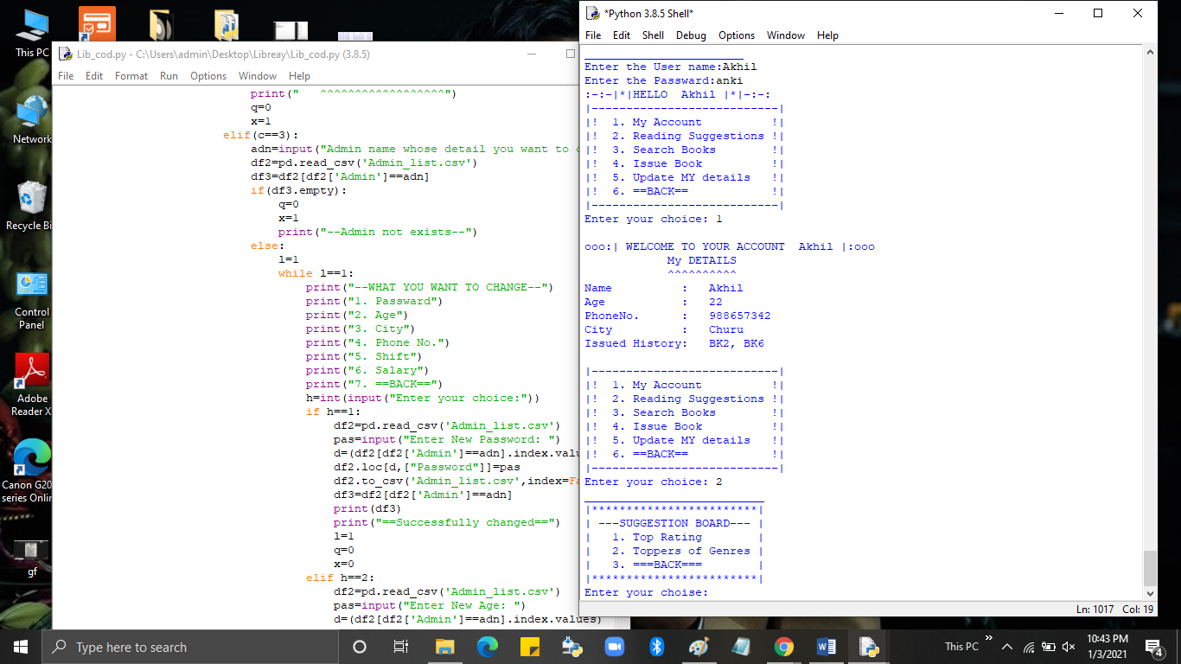

[Top Rating(Bar Chart)]

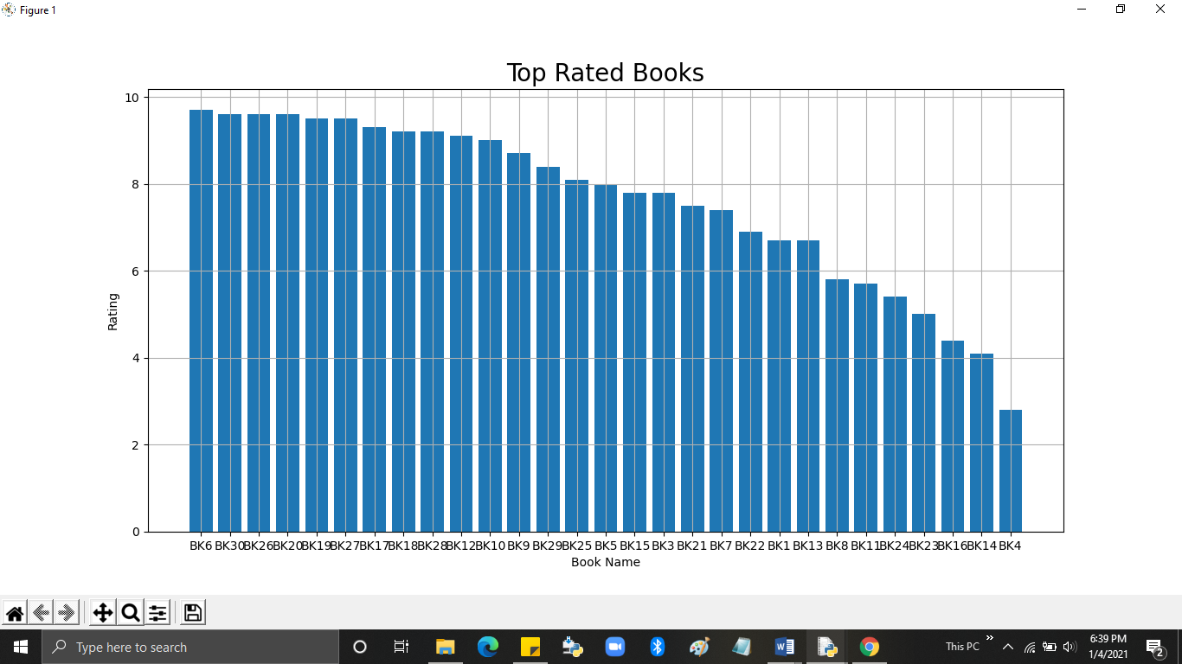

43

[Toppers of Genre(Line Chart)]

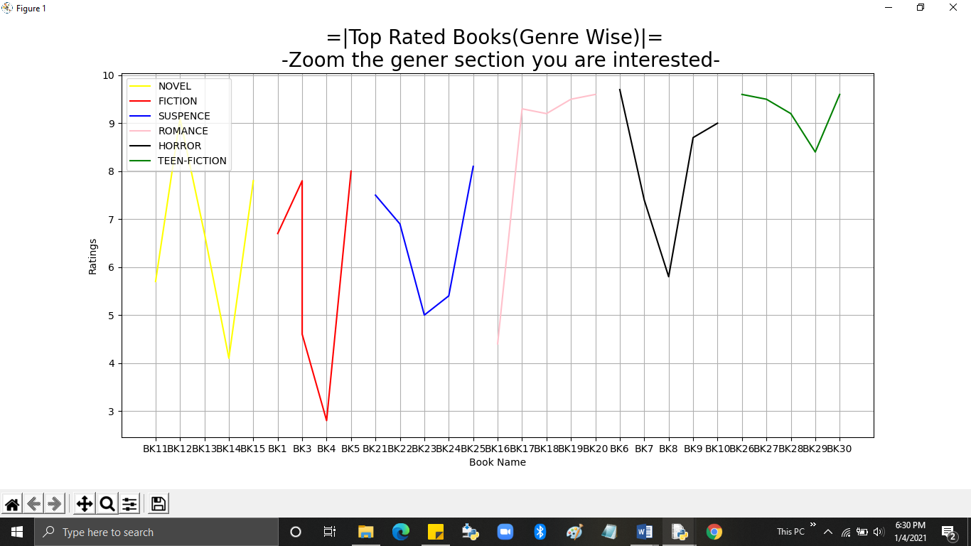

* Search Books-(User can search books they want and check their availability)

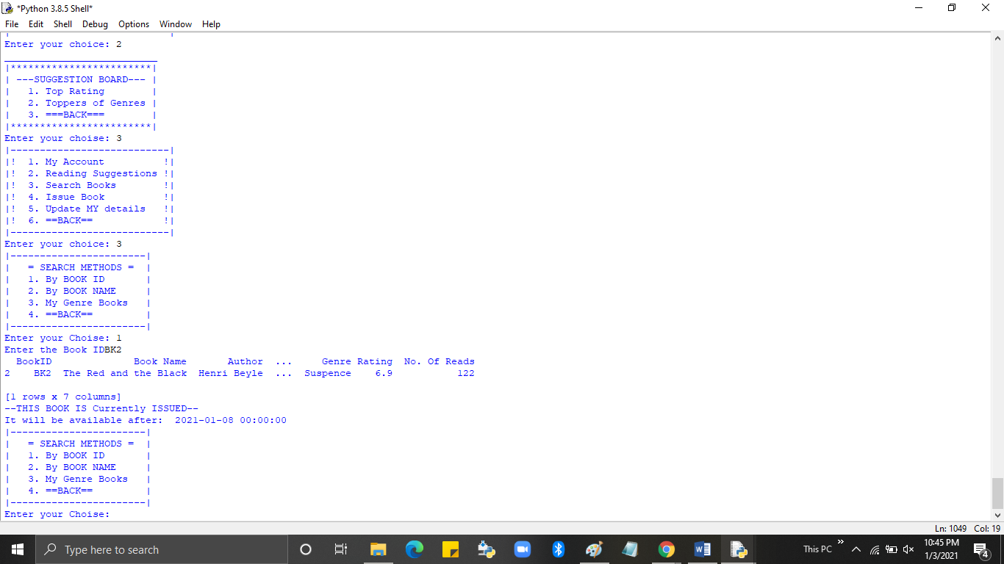

44

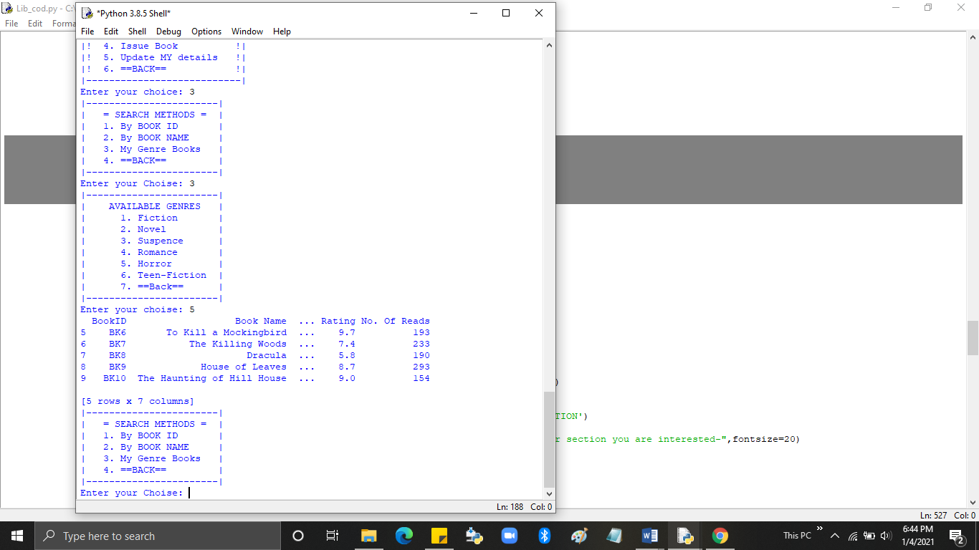

* Issue Book-(User can Issue Book Online)

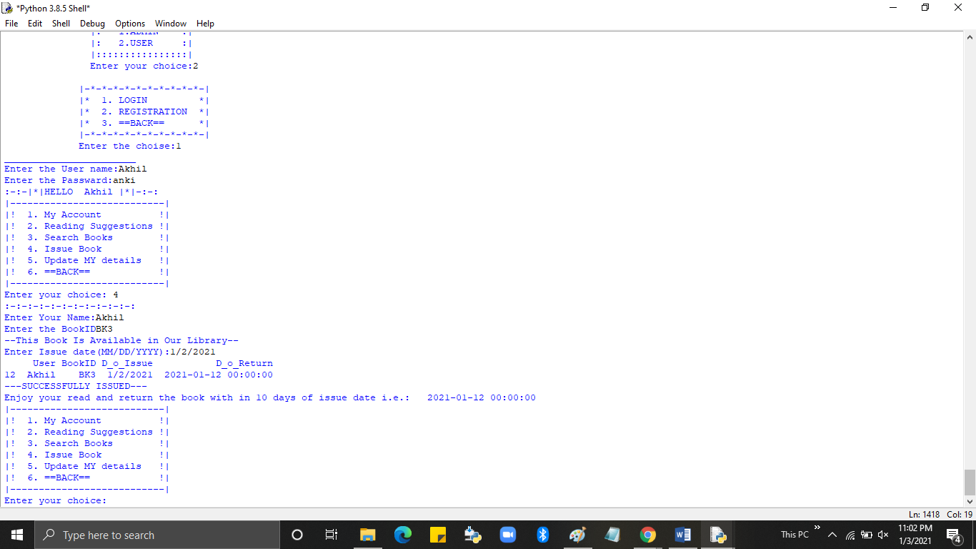

45

* Update My details-(User can update his/her details)

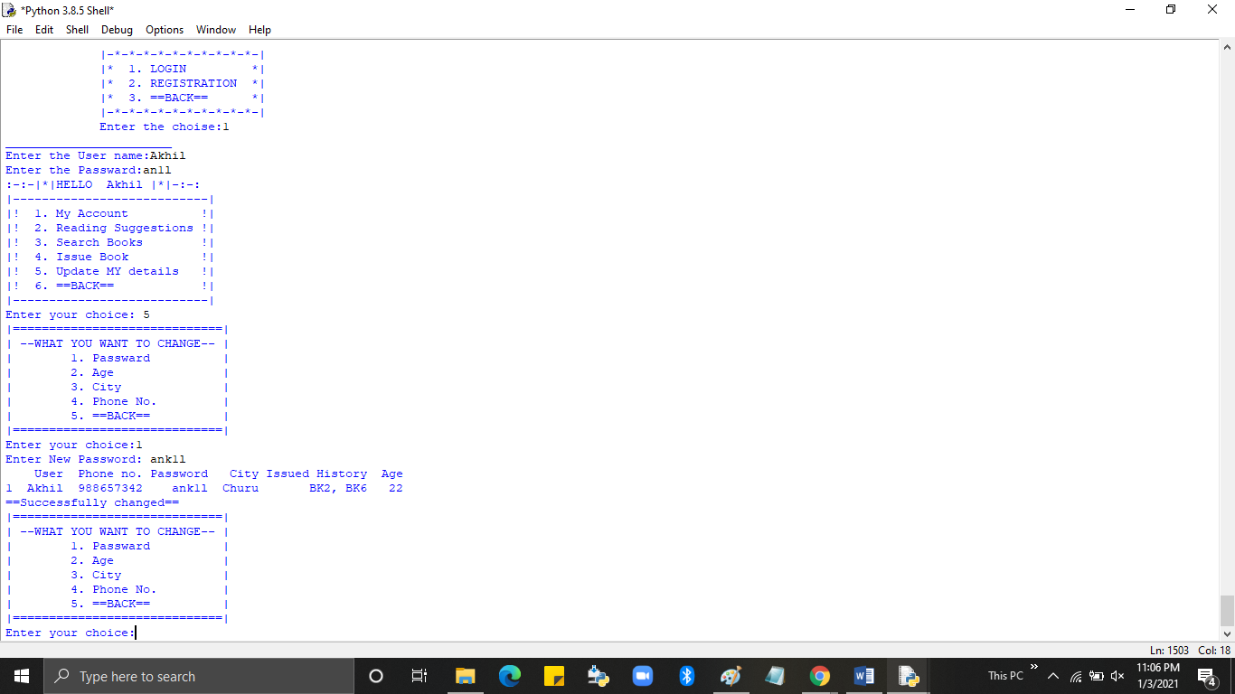

* Registration

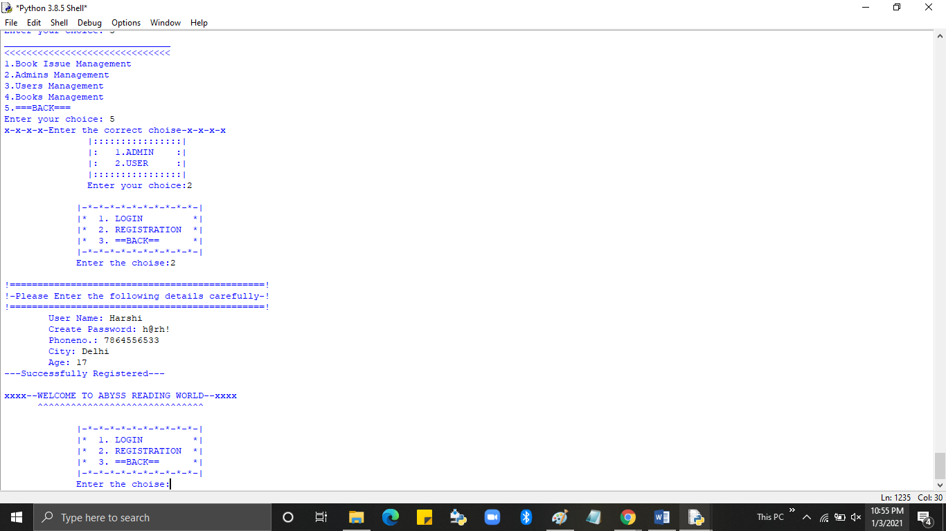

46

**CONCLUSION**

The project entitled *“Abyss Library”*  was completed successfully. The system has been developed with much care and free of errors and at the same time it is efficient and less time consuming*.* The purpose of this project was to develop a web application for give hand to staff of Library to manage their service for readers offline like issuing books, editing etc. Whereas readers have an interactive program to fulfil their needs regarding to their interest in reading Books from this Library.

This project helps us in gaining valuable information and practical knowledge on python language, data visualization using matplotlib and CSV. There is a scope for further development in our project to great extent. A number of features can be added in our system in future like an activity with internet which will make the details entry system convenient or providing the system of having multiple bank account connected with the profile these features could have been implemented unless the time did not limit us.

47

**Bibliography**

* **Website:- > www.stackoverflow.org**

**>** [**www.geeksforgeeks.com**](http://www.geeksforgeeks.com)

48